Athletes Name:_____________________________________________ Grade:_________

This signed paper is due to Coach Cage no later than AUGUST 23rd, 2024.
If this form is not received by the previous date the student- athlete will not practice/compete until this paper is turned in.
By signing this document, I hereby acknowledge that I have digitally received the Handbook by following the QR code at the bottom of this page, read, and understand the team rules and regulations of the SENECA HIGH SCHOOL CROSS COUNTRY HANDBOOK.
Athlete Signature: ______________________________________________________________
Parent-Guardian Signature: ______________________________________________________________

Permission Slip
Riding Home with Parents at an Away Athletic Event

My son/daughter, ___________________________________________________, has permission to ride home for
The entire 2024 Fall sport season (date of event or season) with his/her parents from
All Cross Country Meets and Invitationals (location of event or season).

Parent/Guardian Signature_______________________________________
This form must be turned in to the Main Office the day of the event or beginning of the season for approval by the Principal or Assistant Principal. This form does not require you to pick-up your child from every away event, it simply grants you permission should you choose to do so. As per the rules outlined in this handbook, students are required to sign out with a coach before leaving an event.
Principal/Assistant Principal Signature_______________________________
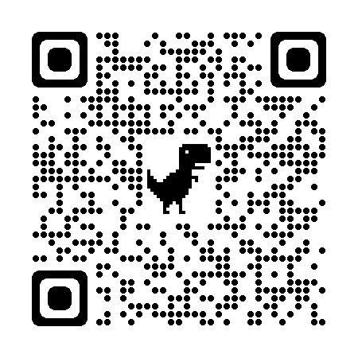
Parent Contact Info:
Name:_______________________________________________________________
Cell Phone: _________________________________________________________
Home Phone: _______________________________________________________
Preferred E-mail: ___________________________________________________
Scan me to go to the XC website and access the handbook online

